The Minnesota Buffer Law
By Joel Wurscher, District Technician

The hot topic right now in the conservation office, here and around the state, revolves around the Buffer Law. This new law has led me, as well as others in the office, to conversations with many familiar and some new faces throughout the county. First, we need to clear up some of the confusion about the term “buffer” we hear in the office. A buffer, also known as a filter strip, is an area of vegetated land adjacent to a body of water such as a stream or lake. Buffers help to filter excess nutrients/sediment to prevent from entering into the water. Buffers also stabilize soil and protect riparian corridors.
Governor Dayton signed this buffer initiative into law in 2015 to enhance the protection of Minnesota’s waters, arguably the state’s best resource! The Governor claims this initiative will help by establishing 90,000 to 110,000 acres of buffers statewide.
Several key events led to the introduction of this law. In 2015, the MPCA published that they had found, no lakes and few streams in the Minnesota portion of the Missouri River Basin met the state standards for supporting aquatic life and were not considered recreationally fishable or swimmable. The agency’s report based its findings on the monitoring and assessment of water quality and aquatic life in four watersheds: Rock, Upper Big Sioux, Lower Big Sioux, and Little Sioux.
The Environmental Work Group (EWG), published that in 37 southern Minnesota counties 8,649 acres of 50-foot buffers were required. At that time, 6,364 acres were present (74 percent of what was required) and 2,285 acres (26 percent of what was required) were found to be absent.
Another ditch buffer study completed in 2014 by the Board of Soil and Water Resources (BWSR) determined that just 12 percent of chapter 103E drainage ditches had triggered the requirement for buffer strips. As it sits today, Sibley County is ahead of the game due to the fact it has been working on the redetermination of benefits process. Currently, Sibley County has 30% of their re-determined ditch systems buffered.
The Basics:
The law states that for all public waters a continuous buffer of perennial rooted vegetation must be in place with an average of 50-feet in width, minimum of 30-feet. This must be in place by November 1st, 2017. For public ditches, a 16.5-foot, or one rod, buffer of perennial vegetation must be in place by November 1st, 2018. To identify parcels you own or rent, view the finalized map completed by the DNR. One can do this by typing in the following, which will direct you right to the map: http://arcgis.dnr.state.mn.us/gis/buffersviewer/ . If you do not have computer access feel free to stop by our office and Ron, Kevin, or I can help you through the process. On this map, waterways lined in green are the areas labeled public ditches while the areas highlighted in blue would be the public waters.
Once these “magic” compliance dates approach and pass, we at the SWCD will determine whether or not each parcel is compliant. This may put quite the strain on us, so please have patience. To ensure compliance statewide, BWSR may withhold funding from a local water management authority or SWCDs if there is failure to implement buffers in their county.
In order to track compliance, a Cloud-based internet tool developed by BWSR will be utilized. The tool should help simplify and streamline the process a bit. As we monitor, we may find parcels that would require corrective action, those cases will be passed to those with jurisdiction to form action plans or fines. These corrective action plans or fines are still a bit of a grey area and have not been completely hashed out yet at the state level.
One way to meet compliance is to request technical and financial assistance through the Conservation Reserve Program (CRP). This program offers eligible landowners/producers yearly rental payments to set aside land like these buffer strips. CRP contracts also provide some cost share opportunities for activities towards establishment and management, making this a very viable option for bringing your buffer into compliance with the law. The minimum width for this program is 30-feet with a max of 120-feet, unless additional water quality benefits can be shown to go wider. The contract length can be anywhere from 10-15 years. Sibley County has seen quite the explosion of interest in CRP which could be attributed to the increase in rental payments we have seen recently. If you or someone you know are interested, stop by the USDA service center for more information.
The SWCD and County plan on hosting public informational meetings around August/September (before harvest) and then again mid-winter. The goal of these meetings is to get the word out about the law and help answer any of the questions you may have. Also at these meetings, we plan to have breakout sessions providing computer access to help determine the size of buffer you need. Stay tuned, because these dates have not been set but will be announced shortly.
It’s a very busy but exciting time in conservation right now. I look forward to working with you on implementing these buffer strips on your property! If you are unable to participate in the informational meetings or would just like some technical assistance, please contact our office at 507-237-5435 ex. 3.

Attached Pictures:
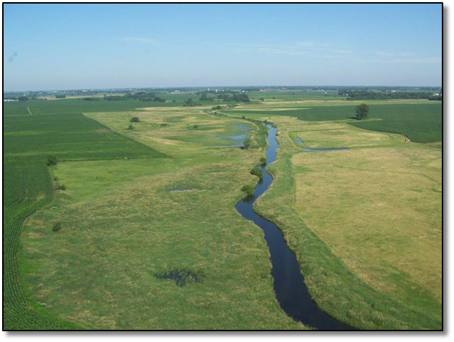

Buffer along the mainstem of High Island Creek West of Arlington

